The individual student work 1
- Configure the following network topology
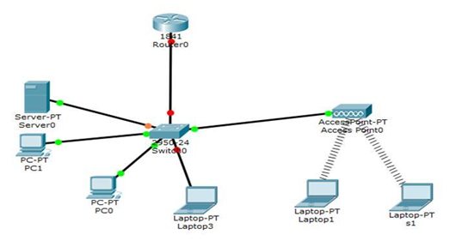
- Assign corresponding ip addresses to the router and host devices
- Make sure that these devices can communicate with each other by using the ping command

